

SIMATS SCHOOL OF ENGINEERING
SAVEETHA INSTITUTE OF MEDICAL AND TECHNICAL SCIENCES
CHENNAI-602105

ASSESSMENT 1
CSA1006-SOFTWARE ENGINEERING

Problem 2: Feasibility Study for a Smart Parking System
SUBMITTED BY:
SRUTHI J – 192371085

Scenario:
A startup plans to develop a Smart Parking System that uses IoT sensors and a mobile application to help drivers find and reserve available parking spaces in real time. Before investing in the project, the company
needs to determine whether the system is technically, operationally, and
financially feasible.

- Feasibility Analysis

- Technical Feasibility

Technical Requirements
- IoT sensors to detect parking space availability.
- Mobile application for users to locate and reserve parking spaces.
- Cloud database for storing parking information.
- Internet connectivity for real-time updates.
- GPS integration for navigation.
Feasibility
- The required technologies are already available and widely used.
- Cloud platforms and IoT devices make implementation practical.
- The project is technically feasible with current technology.
Example
Many modern shopping malls already use sensor-based parking systems that display available parking slots to drivers.
\
- Operational Feasibility

Operational Requirements
- Parking authorities should manage available parking spaces.
- Drivers should easily use the mobile application.
- Staff should receive training to monitor and maintain the system.
- Regular maintenance of sensors and servers is required.
Feasibility
- Users can quickly learn the application.
- Parking management becomes more efficient.
- Reduces traffic congestion and saves time.
Example
Drivers can reserve a parking space before arriving, reducing the time spent searching for parking.

c) Financial Feasibility
Estimated Costs
- Purchase of IoT sensors.
- Mobile application development.
- Cloud server and database maintenance.
- Installation and maintenance costs.
Expected Benefits
- Increased parking revenue.
- Reduced traffic congestion.
- Improved customer satisfaction.
- Lower operational costs through automation.
Cost-Benefit Summary
Although the initial investment is high, the long-term benefits and increased revenue make the project financially feasible.

- Design Thinking Activity

User Interviews
The company should conduct interviews with:
- Drivers
- Parking lot managers
- Security staff
Purpose
- Understand parking problems faced by users.
- Identify desired mobile app features.
- Improve user experience before development begins.
Example
Drivers may request features such as:
- Real-time parking availability.
- Online payment.
- Parking reservation.
- Navigation to the reserved parking slot.

3. Block Diagram
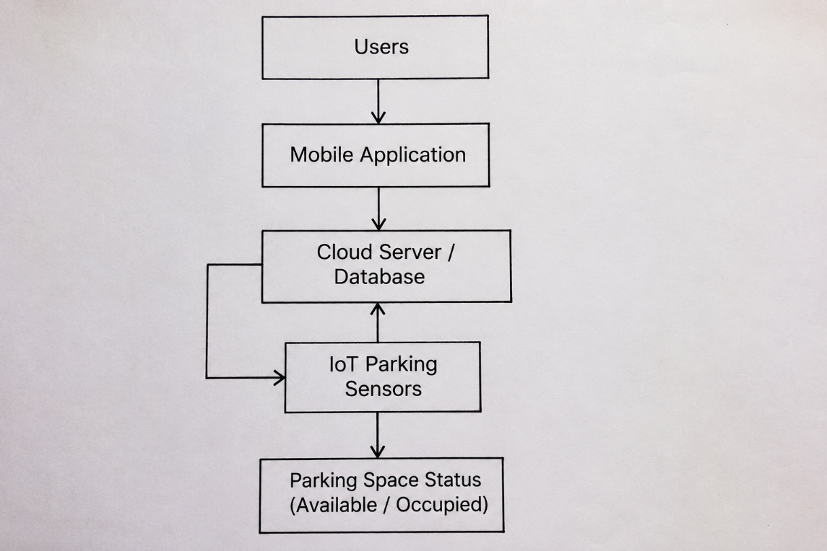
Real-World Example
Many airports and shopping malls use smart parking systems that display available parking spaces through sensors and mobile applications.
To improve the system, the company:
- Installs reliable IoT sensors.
- Develops an easy-to-use mobile application.
- Uses cloud technology for real-time updates.
- Collects user feedback to improve services.
- Performs regular maintenance of sensors.
This results in a faster, more efficient, and user-friendly parking experience.

Conclusion
A Smart Parking System is technically, operationally, and financially feasible using existing IoT and mobile technologies. Conducting user interviews helps understand customer needs and improves the system design. By carefully evaluating feasibility before development, the company can reduce risks, improve efficiency, and provide a reliable parking solution for users.

